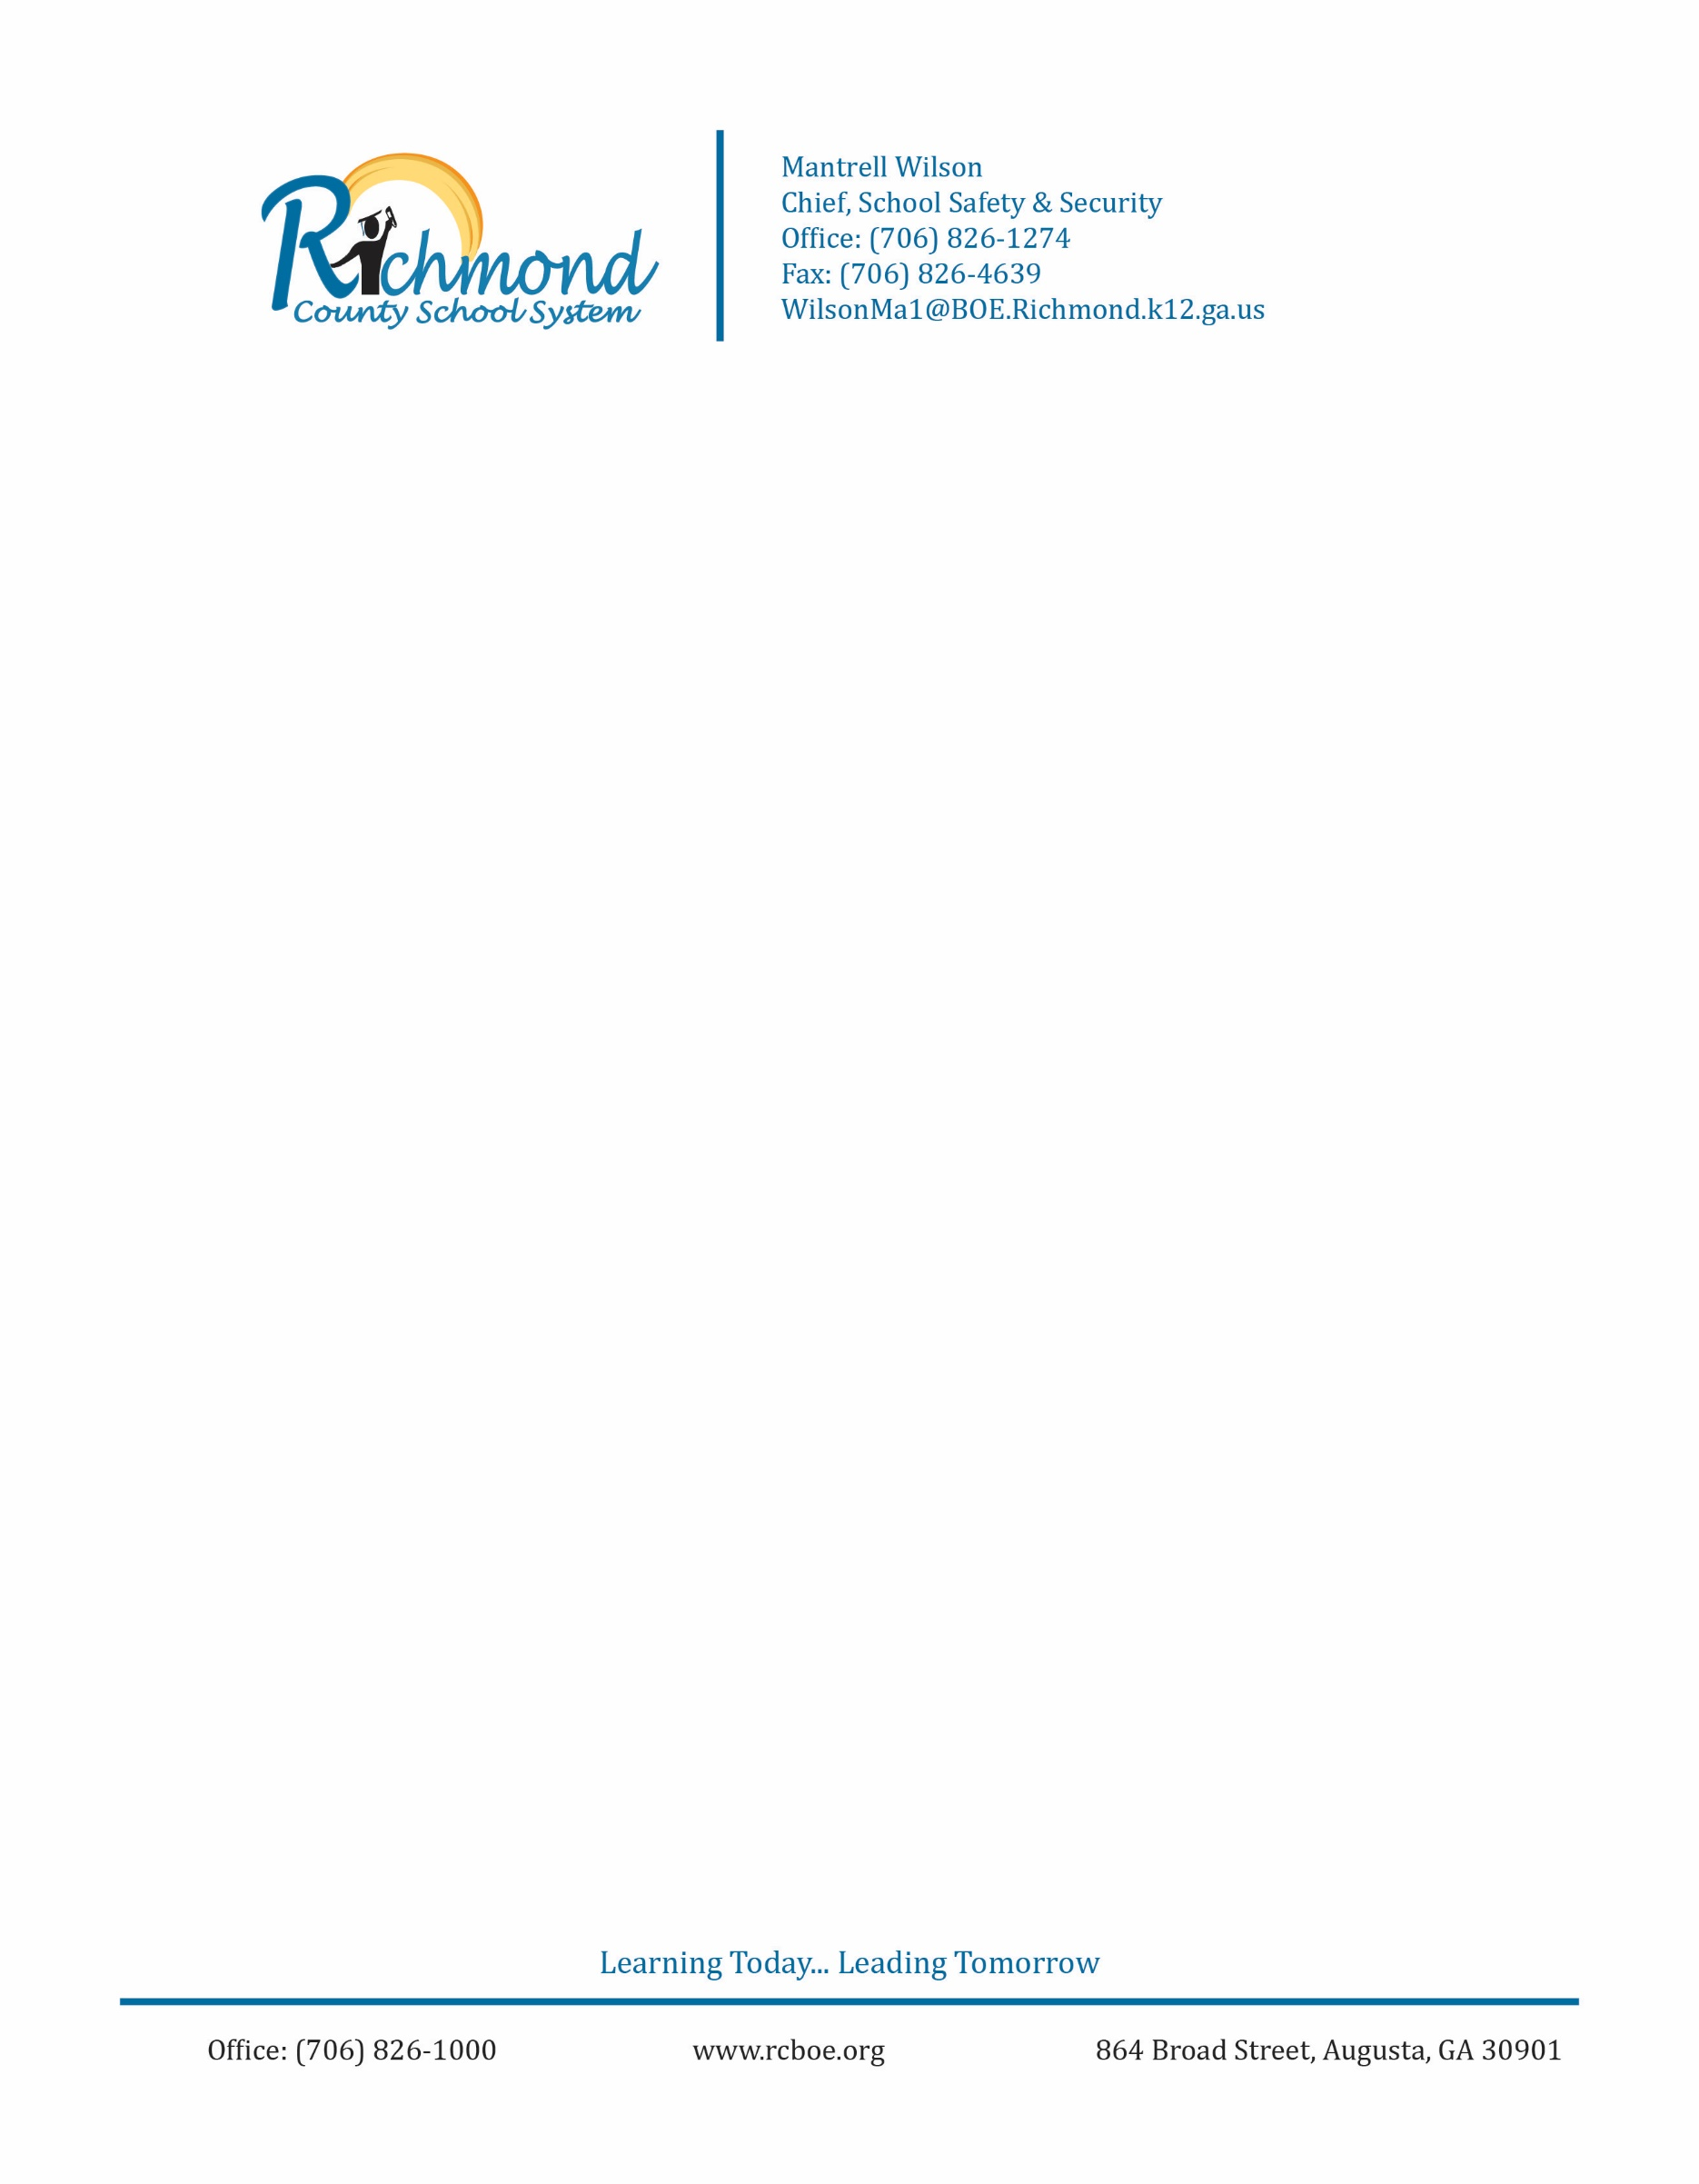

**Citizen Complaint Form**

Dear Complainant,

A relationship of trust and confidence between employees of the police department and the community they serve is essential to effective law enforcement. Law enforcement officers must be free to exercise their best judgment and initiate enforcement actions in a reasonable, lawful, and impartial manner without fear of reprisal, while at the same time, having a special obligation to respect the rights of all persons.

The Richmond County School System (RCSS) Department of School Safety and Security acknowledges its responsibility to establish a system of complaint and disciplinary procedures in efforts to promote transparency and accountability. These procedures will not only subject the officers to corrective action should they conduct themselves improperly, but they also serve to safeguard the officer from unwarranted criticism should their actions be found lawful and appropriate.

It is the purpose of these procedures to provide prompt, open, and expeditious disposition of complaints regarding the conduct of employees of the police department. To this end, citizens are encouraged to bring complaints about department operations and the conduct of its employees whenever they believe that such an act is improper.

As a complainant, you should be aware that police officers have the right, as do all citizens, to pursue civil actions against a person making false claims of improper action.

Sincerely,

Mantrell Wilson

Director of Public Safety

O.C.G.A. 16-10-20 (2010)

16-10-20. False statements and writings, concealment of facts, and fraudulent documents in matters within jurisdiction of state or political subdivisions   
  
  
A person who knowingly and willfully falsifies, conceals, or covers up by any trick, scheme, or device a material fact; makes a false, fictitious, or fraudulent statement or representation; or makes or uses any false writing or document, knowing the same to contain any false, fictitious, or fraudulent statement or entry, in any matter within the jurisdiction of any department or agency of state government or of the government of any county, city, or other political subdivision of this state shall, upon conviction thereof, be punished by a fine of not more than $1,000.00 or by imprisonment for not less than one nor more than five years, or both.

Please write you complaint here. You may use the back of this form should you need additional space.

________________________________________________________________________________________________________________________________________________________________________________________________________________________________________________________________________________________________________________________

______________________________________________________________________________________________________________________________________________________________________________________________________________________________________________________________________________________________________________________________________________________________________________________________________________________________________________________________________________________________________________________________________________________________________________________________________________________________________________________________________________________________________________________________________________________________________________________________________________________________________________________________________________________________________________________________________________________________________________________________________________________________________________________

________________________________________________________________________________________________________________________________________________________________________________________________________________________________________________________________________________________________________________________

________________________________________________________________________________________________________________________________________________________________________________________________________________________________________________________________________________________________________________________________________________________________________________________________________________________________________________________________________________________________________________________________________________________________________________________________________________________________________________________________________________________________________________________________________________________________________________________________________________________________________________________________________________________________________________________________________________________________________________________________________________________________________________________________________________________________________________________________________________________________________________________________________________________________________________________________________________________________________________________________________________________________________________________________________________________________________________________________________________________________________________________________________________________________________________________________________________________

I, (name) _________________________________ hereby swear (or affirm) that the preceding statement is true and accurate to the best of my knowledge and recollection.

Signature: ________________________________________Date/time: ___________________

Witness Signature: _________________________________Date/time: ___________________

**FINDINGS**

□ **Sustained: Evidence sufficient to prove allegations**

□ **Not sustained: Insufficient evidence to prove or disprove allegations**

□ **Exonerated: Incident occurred but was lawful or proper**

□ **Unfounded: Allegation is false or not factual**

□ **Policy failure:** **Flaw in policy caused incident**

**Investigated By: ____________________________________________**

**Reviewed By: _________________________________________________**

**CHIEF’S ACTIONS**

______________________________________________________________________________________________________________________________________________________________________________________________________________________________________________________________________________________________________________________________________________________________________________________________________________________

__________________________

**Mantrell Wilson, Director of Public Safety**